National Research University Higher School of Economics (Higher School of Economics/HSE)

Faculty of Computer Science

Bachelor's Programme Data Science and Business Analytics

01.03.02 Applied Mathematics and Computer Science

**Internship report**

Fulfilled by

Tafintseva Albina Vadimovna,

Demchenko Karina Aleksandrovna,

Yakunina Kseniya Pavlovna

*(Surname, Given Name, Middle Name if any)*

**____________________________**

*(signature)*

**Checked by**

|  |  |  |
| --- | --- | --- |
| _______________________________ | *____________________* | ________________ |
| (job or academic title) | (*surname, initials)* | (signature) |

**Moscow, 2019**

**Contents:**

**1.** Introduction

**2.** Educational Internship Schedule (Plan)

**3.** Description of the learned materials

1. Description of the results
2. Conclusion
3. Bibliography
4. Appendix and supplementary material (charts, graphs, pictures, etc.)

**Introduction**

**Internship goals***)***:** consolidation, expansion and deepening of the theoretical knowledge and acquirement of initial practical skills in solving specific problems

**Tasks**

* 1. consolidation and deepening of the theoretical knowledge on the disciplines passed at the university;
  2. acquirement of information competence for the purpose of successful work in professional activities;
  3. obtaining skills of both independent and team work.

**Contents**:

1. Work with NetworkX and Matplotlip
2. Visualization of Graph
3. Realization of Karger’s algorithm
4. Study VK API method for communities

**Educational Internship Schedule (Plan)**

|  |  |  |  |
| --- | --- | --- | --- |
| № | **Calendar period** | **Work Plan** | Internship Supervisor’s signature/ |
| 1 | 01.07.2019 | 1. Organizational (induction) meeting |  |
| 2 | 01.07.2019 | 2. Instructing on the requirements of labor protection, safety, fire safety and internal labor regulations |  |
| 3 | 01.07.2019 -13.07.2019 | 3. Fulfillment of Individual Assignment |  |
| 4 | 01.07.2019 -13.07.2019 | 4. Consultation |  |
| 5 | 14.07.2019 | 5. Preparation and submission of the Report |  |

**Description of the learned materials**

1. For the assignment, information was studied about the Karger algorithm to find the minimum cut.

2. Studied documentation Vk Api

3. Studied documentation Networkx, Matplotlip

4. Studied materials for working with links in the Python programming language.

**Description of the results**

1. Got members from community and converting it into list
2. Got pairs of friends
3. Created visualization of graphs for 500 people
4. Implement Karger’s algorithm for test graph

**Conclusion**

For the practice project, we chose the official group of the Higher School of Economics (https://vk.com/hse_university).

  We had to analyze randomly selected community members for social connections.

 We randomly selected 1000 participants from all the group members (72,229) and created a list of their ID with the help of Vk Api.

Further for each selected participant we requested a list of his friends using Vk Api to check if he has friends who are also members of this group.  All this is displayed in the form of a list of pairs where each pair is represented by a pair of friends, however for this we re-formed the ID of each person into the Name and Surname of the participant, since this contributes to a pleasant and understandable visualization of the graph.

  The next step was using Networkx and Matplotlip to build a social connection graph.

This graph is presented in the form where the vertices are the names of the participants, and the edge exists if two participants are friends in the social network.

An attempt was made to implement the Karger algorithm, but our implementation works only for the test case for finding the minimum cut, with a graph of 4 vertices.

**Bibliography**

NetworkX Reference,Release 2.4rc1.dev20190629231041/Aric Hagberg, Dan Schult, Pieter Swart**/**29.06.2019/ p. 1-2, 499-505

<https://networkx.github.io/documentation/latest/_downloads/networkx_reference.pdf>

Matplotlip documentation release 3.1.1/02.07.2019

<https://matplotlib.org/3.1.1/contents.html>

Алгоритм Каргера для нахождения минимального разреза/Университет Итмо/послежние обновление 05.02.2018

<https://neerc.ifmo.ru/wiki/index.php?title=Алгоритм_Каргера_для_нахождения_минимального_разреза>

Karger's algorithm – Wikipedia/last update 09.06.2019

<https://en.wikipedia.org/wiki/Karger's_algorithm>

Описание методов API

<https://vk.com/dev/methods>

**Supplementary material**

**Graphs for 500 users.**

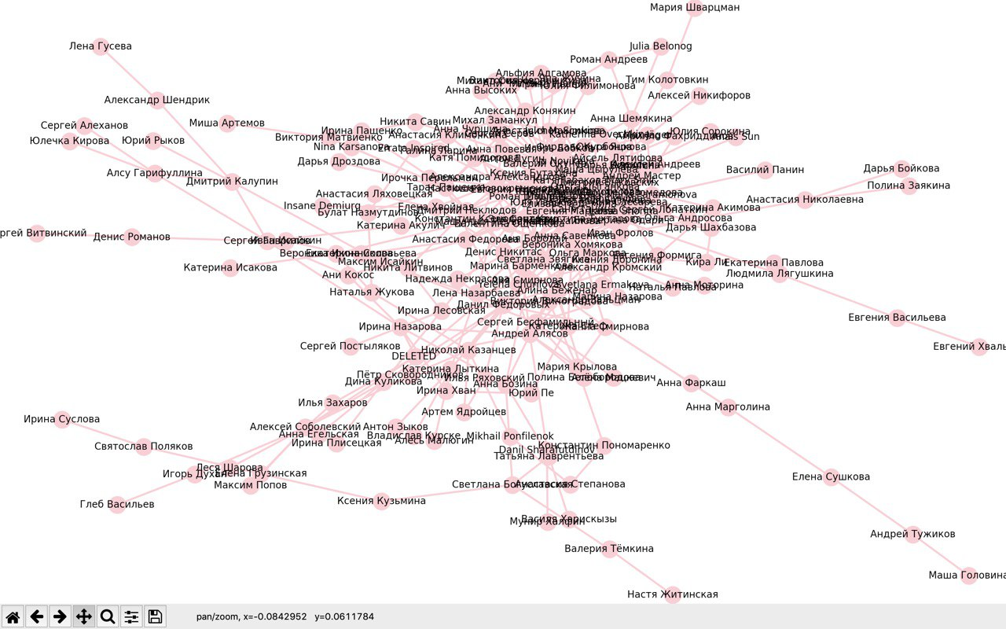

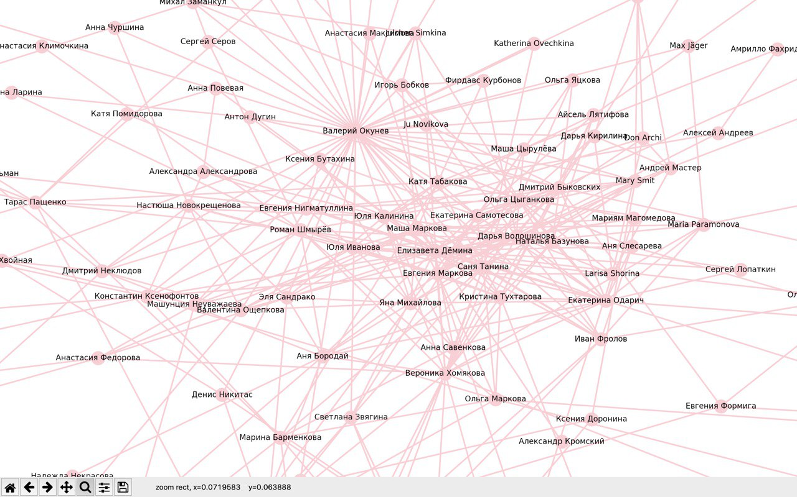

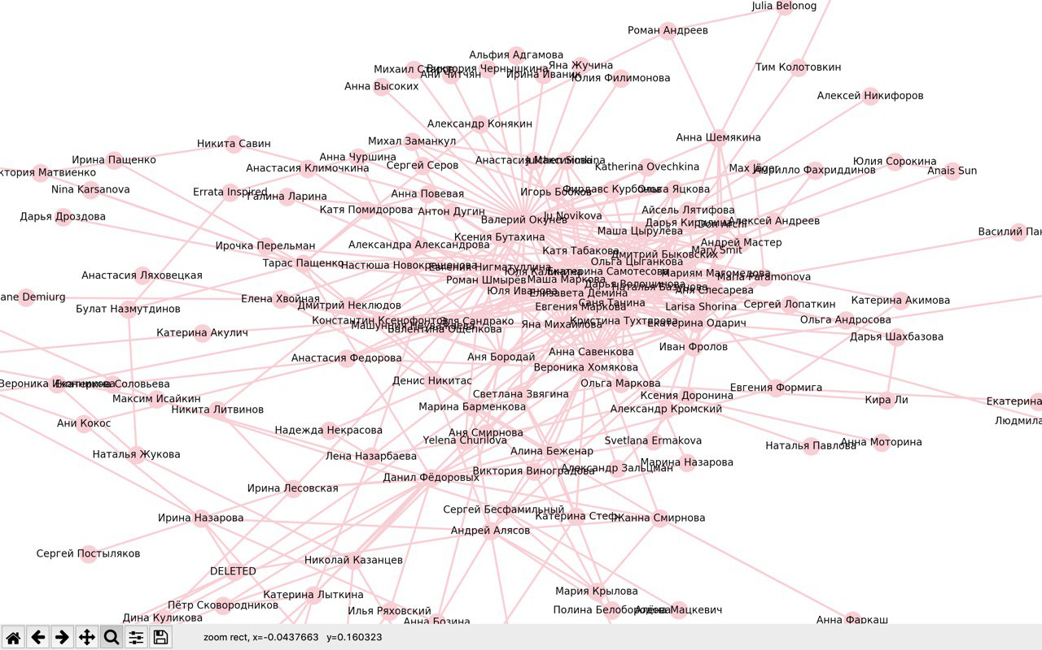

**Graph for Karger’s algorithm**

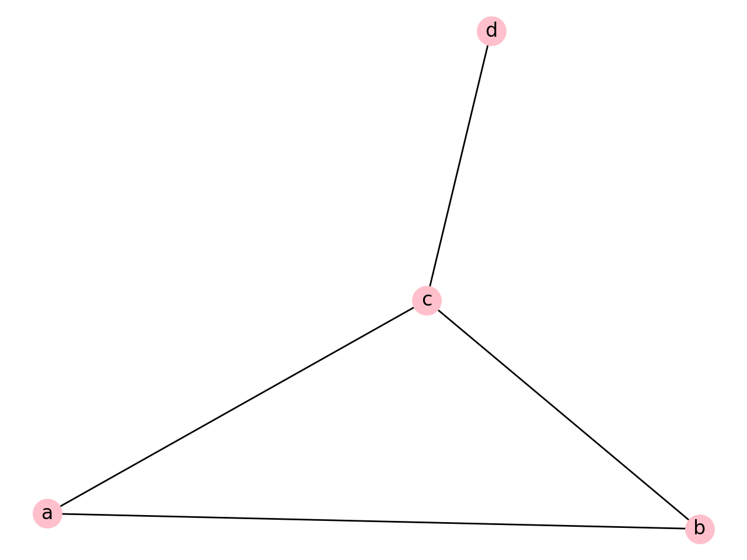

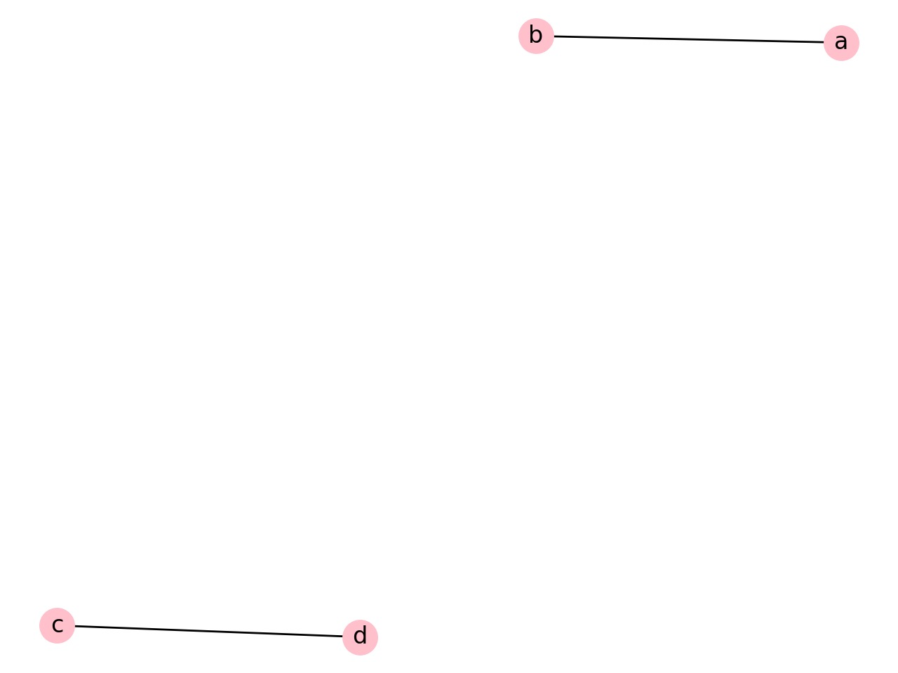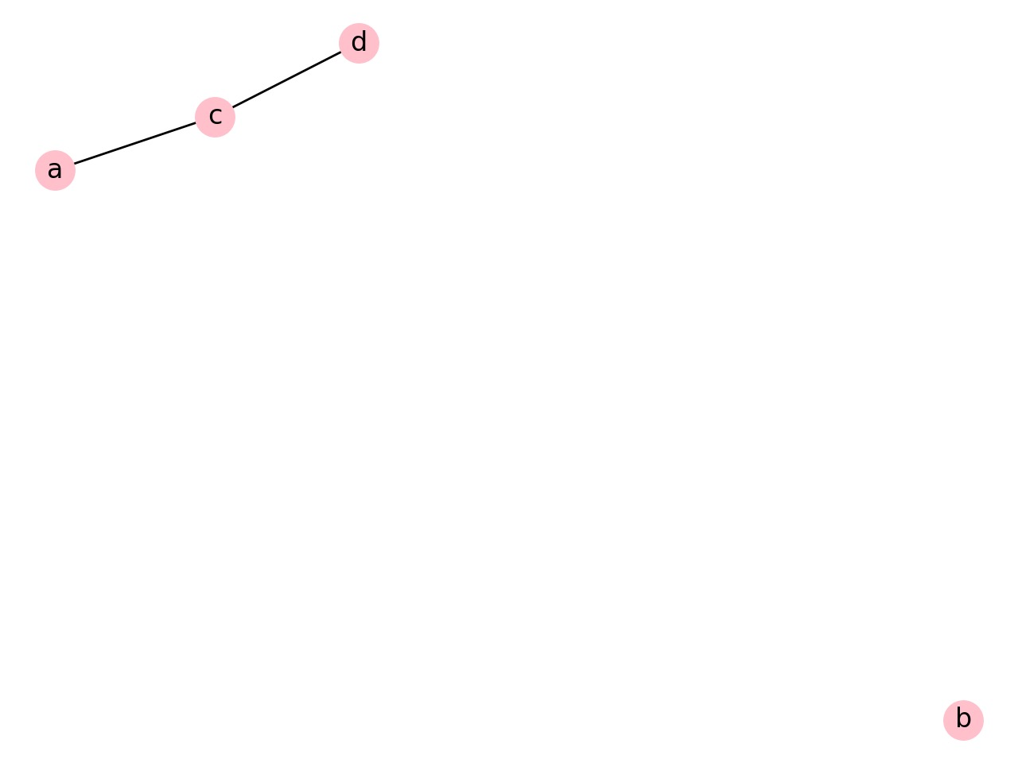

**Examples of cuts**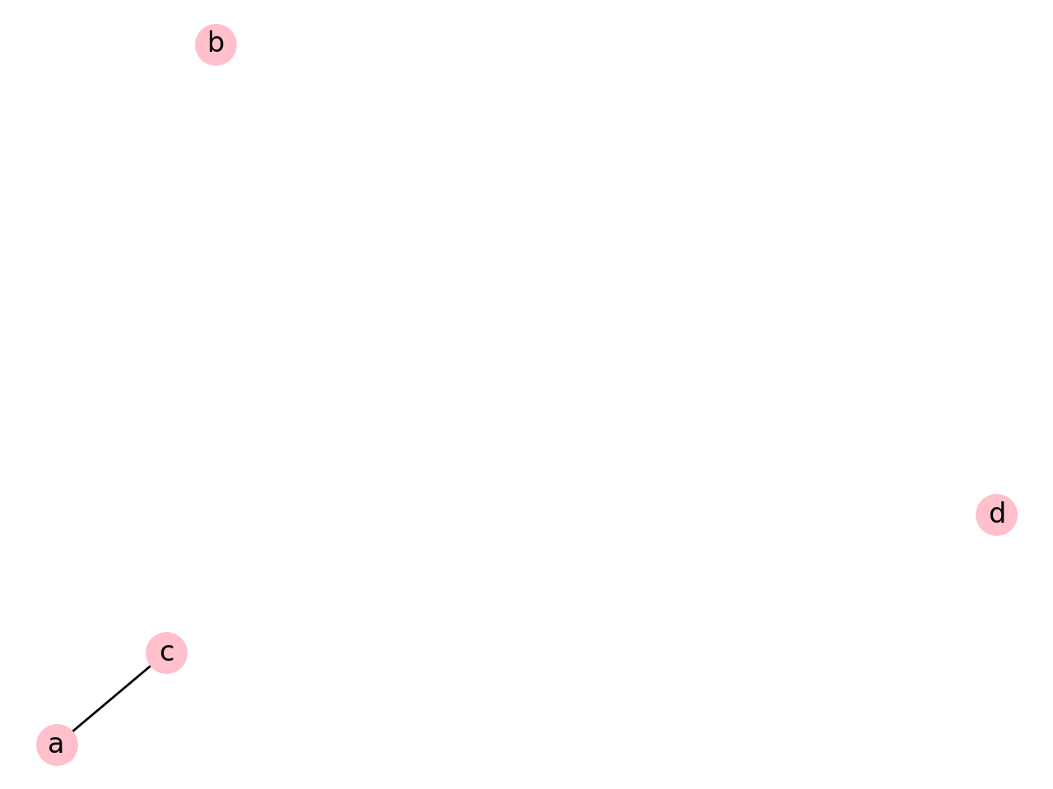

**Example of mincut.**